

Assessment Cover Page
Student Full Name | Thaninnada Samart
Student Number | 2026781
Module Title | Strategic Thinking
Assessment Title | CA 1 – Capstone Project Proposal
Lecturer/Supervisor | Taufique Ahmed
Assessment Due Date | 21-Sep-2026
Date of Submission | 21-Oct-2026

Use of AI Tools
I acknowledge the use of perplexity.ai only to support brainstorming for my project. I used it to explore possible ideas and structure the information, while retaining responsibility for the project content and final decisions.
Declaration
By submitting this assessment, I confirm that I have read the CCT policy on academic misconduct and understand the implications of submitting work that is not my own or does not appropriately reference material taken from a third party or other source.
I declare it to be my own work and that all material from third parties has been appropriately referenced.
I further confirm that this work has not previously been submitted for assessment by myself or someone else in CCT College Dublin or any other higher education institution.

Capstone Project Proposal
A Predictive Analytics Solution for Identifying Depression Risk Among Older Adults

Thaninnada Samart

Strategic Thinking

Lecturer: Taufique Ahmed

CCT College Dublin

21th October 2026

https://github.com/thaninnada/Strategic_Thinking_Sep2026
Contents
Introduction 2
Business Problem Definition 3
Objective 3
Project Scope 3
Project Methodology and Plan 4
First Semester 4
Second Semester 4
Project Timeline 5
Data Sources 6
Data Permissions 6
Data Science Approach 6
Ethical and Legal Considerations 6
References 8
Use of Artificial Intelligence 9
AI Declaration using the AI Fluency Framework 9
Adapted from the AI Fluency Framework (Dakan, Feller, Anthropic, 2025). 10
Appendix 11

Introduction

The global population is ageing rapidly. Statistics from the World Health Organisation (WHO, 2025) finds that approximately 1.1 billion people aged 60 and over are currently living worldwide in 2023. This number is predicted to pass over 2.1 billion by 2025. Mental health conditions in the elderly population often go unrecognized especially in relation to depression which often goes untreated.
Healthcare organisations face challenges in identifying risk factors such as social isolation, chronic illnesses and financial difficulties which are often related to depressive symptoms.
This project will examine demographics, socioeconomic and health related risk factors that are associated with the depressive symptoms. Using predictive analytics to explore and identify high risk groups, support screening priorities and planning resource allocation. The goal of the project is not to predict future onset or provide clinical diagnostics.

Business Problem Definition
The health care sector faces many challenges when it comes to identifying risk factors associated with depression (WHO, 2025). An evidence based approach is needed to better identify the risk factors that support effective screening and planning (NIA, 2025).
The aims of this project are to examine the factors associated with depression in older adults and use cross sectional data collected at a single point in time. Using predictive analytics I aim to identify patterns and groups more likely to be in a high risk group in relation to depressive disorders. This analysis will be used to support evidence based screening, prioritisation and resource allocation.

Objective
The objectives of this project are as follows:
- Study the main factors related to depression in the elderly population such as demographics, socioeconomics and health factors.
- Identify the patterns, subgroups and individuals related to the elderly population that are prone to depression using data from a cross sectional study.
- Develop a predictive analytics approach to identify individuals who may benefit from further screening and assessment.
- Demonstrate how these results can assist health agencies in allocating resources effectively.

Project Scope
The project focus is to examine how predictive analytics (Khorram, 2026) can be used to identify patterns and factors associated with depression in the elderly population.
Inclusions:
- Analyse factors associated with depression in the elderly population such as demographic, socio-economics and health status.
- Identify patterns related to higher risk groups prone to exhibiting symptoms of depression.
- Apply appropriate techniques to analyse the relationships among the relevant variables.
- Evaluate the results of the predictive analysis to see whether they support the early detection of symptoms.
Exclusions:
- The project does not intend to be used as a predictive resource in clinical settings or as a replacement for the judgement of healthcare professionals.
- The program is not intended to be used to proscribe treatments or as a tool for recommendations to individual patients.

Project Methodology and Plan

First Semester
- Phase 1: Data Collection and Preprocessing (Weeks 1–4)
Exploration and selection of dataset cleaning and preparation for analysis. Inclusions are identify data types, missing values, checking inconsistencies and assessing suitability of variables. The variables that are relevant to the selection process include demographic, socioeconomic and health status.
Expected Outcome: Create a clean well-structured data set that is ready for analysis.

- Phase 2: Exploratory Data Analysis (Weeks 4–8)
Exploratory Data Analysis (EDA) that will examine the distribution of symptoms and investigate the relevant relationships. Create statistical summaries and data visualisations to identify patterns and differences between groups.
Expected Outcome: EDA report presenting key findings and the visualizations of main factors.
- Phase 3: Model Development (Weeks 7–12)
Development of a predictive model that determines the relevant factors that distinguish between older adults that have a history of depression and those that do not. This will utilise cross-sectional data that will be used to interpret and predict future depression. The models performance and outcomes will be aligned to the defined business objectives.
Expected Outcome: Candidate classification models that identify older adults that have both a history of reported depression and those without in alignment with supporting business decision making.

Second Semester
- Phase 4: Model Evaluation and Optimization (Weeks 1–4)
Evaluate the predictive models performance metrics and interpretability refining as necessary.
Expected Outcome: Finalised and optimised models with documented performance metrics.
- Phase 5: Business Insights and Decision Support (Weeks 5–8)
Analyse results and access how the findings can be used to assist healthcare outcomes and prioritise respondents for further assessment. Plan support services and allocate resources.
Expected Outcome: A detailed report presenting evidence that inform business decisions.
- Phase 6: Final Refinements and Presentation (Weeks 9–12)
Refinement and improvement based on recommendations and feedback, create the final project report and prepare a presentation for the study.
Expected Outcome: Completed project submission that includes the final report and presentation materials.

Project Timeline
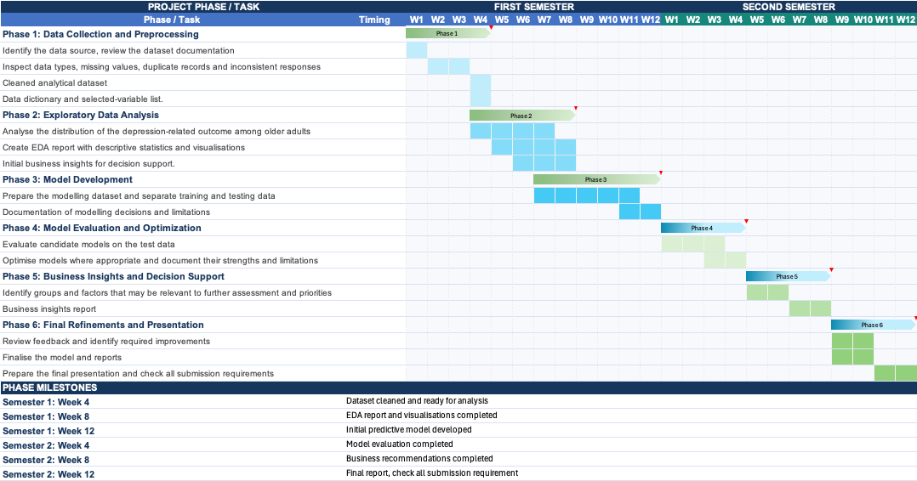
Figure 1 - High-level project timeline

Data Sources
The project uses data that is publicly available from the National Health and Nutrition Examination Survey (NHANES) August 2021–August 2023 which was conducted by the National Center for Health Statistics (NCHS) a part of the U.S. Centers for Disease Control and Prevention (CDC). The study focuses on adults aged 60 and over and will use PHQ-9 (NCBI, 2020) responses to depression along with demographic, socioeconomic and health related risk factors.

Data Permissions
The dataset is publicly available for research purposes. The project will comply with the NCHS data use requirements and maintain participant confidentiality and acknowledge data sources.

Data Science Approach
The proposed analytics solution architecture below illustrates the process from data collection and preparation through to analysis and model evaluation and business insights.
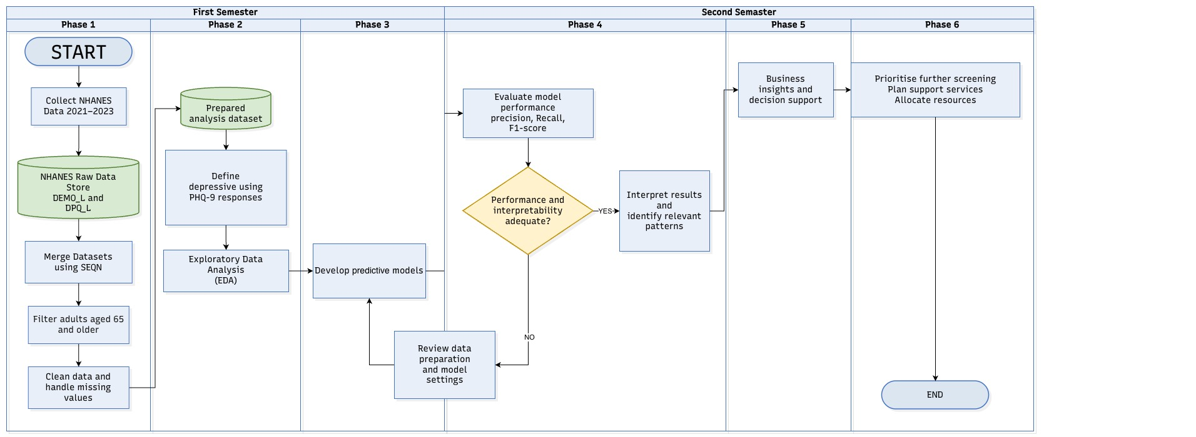
Figure 2 - Diagram for Identifying Depressive Symptoms Among Older Adults

Ethical and Legal Considerations
As the Project will be using publicly available data there should be no significant privacy concerns (Library, 2026). Even so the following ethical considerations will be included.
- Data Privacy: Using public NHANES data in accordance with data use requirements and protect participant confidentiality.
- Data Governance: Check data for missing values and inconsistencies and document data preparation and analytical decisions.
- Bias and Fairness: Evaluate potential bias in the data and model performance across demographic groups to avoid incorrect conclusions.
- Transparency and Accountability: Provide clear reporting methods, results and limitations without overestimating performance or implying causation.
- Responsible Use and Legal Compliance: Following all applicable data-protection principles and legal requirements. Use findings to support screening and service planning and not as a clinical diagnosis or in the prediction of future depression onset.

References
Chunjam, S., Sangon, S. and Thaweekoon, T. (2011) ‘A survey of depression research in Thailand’, Rama Nursing Journal, 17(3), pp. 412–429. Available at: https://www.rama.mahidol.ac.th/ramanursej/sites/default/files/Public/journal-files/RNJ-V17-N03-OCT-DEC-2011-08.pdf (Accessed: 14 October 2026).
Cote, C. (2021) ‘5 Principles of Data Ethics for Business’, Harvard Business School Online, 16 March. Available at: https://online.hbs.edu/blog/post/data-ethics (Accessed: 15 October 2026).
Kengganpanich, M., Pengpid, S. and Peltzer, K. (2023) ‘Predictors of and healthcare utilisation of depressive symptoms among middle-aged and older adults in Thailand: a national cross-sectional community-based study in 2015’, BMJ Open, 13(10), e071980. Available at: https://doi.org/10.1136/bmjopen-2023-071980.
Khorram, B., Nilforooshan, R., Barnaghi, P. and Kouchaki, S. (2026) ‘Prediction of clinically significant depressive symptoms at 2-year follow-up in older adults: machine learning study using the English Longitudinal Study of Ageing’, JMIR Formative Research, 10, e84744. Available at: https://doi.org/10.2196/84744.
Kvalbein-Olsen, L.C., Aakhus, E., Haavet, O.R. and Werner, E.L. (2023) ‘Unrecognised depression among older people: a cross-sectional study from Norwegian general practice’, BJGP Open, 7(1), BJGPO.2022.0135. Available at: https://doi.org/10.3399/BJGPO.2022.0135.
Luca, C. (2025) Data Governance and Ethical Considerations in Business Analytics Implementation. Available at: https://www.researchgate.net/publication/393715319_Data_Governance_and_Ethical_Considerations_in_Business_Analytics_Implementation (Accessed: 15 October 2026).
National Institute on Aging (2025) Depression and Older Adults. Available at: https://www.nia.nih.gov/health/mental-and-emotional-health/depression-and-older-adults (Accessed: 6 October 2026).
Pongsorn, S. (2019) The Study of Depression, Quality of Life, and Associated Factors among Caregivers and Patients with Peritoneal Dialysis in Thailand. Master’s thesis. Chulalongkorn University. Available at: https://digital.car.chula.ac.th/chulaetd/9106/ (Accessed: 14 October 2026).
University College Dublin (UCD) Library (n.d.) Research Data Management: Ethical Considerations. Available at: https://libguides.ucd.ie/data/ethics (Accessed: 15 October 2026).
World Health Organization (2021) Comprehensive Mental Health Action Plan 2013–2030. Geneva: World Health Organization. Available at: https://iris.who.int/server/api/core/bitstreams/69921758-6229-49ba-bd3d-c24736e35829/content (Accessed: 7 October 2026).
World Health Organization (2025) Mental health of older adults. Available at: https://www.who.int/news-room/fact-sheets/detail/mental-health-of-older-adults (Accessed: 6 October 2026).

Use of Artificial Intelligence
This assessment applies the AI Fluency Framework — four interconnected competencies for effective, efficient, ethical and safe AI use. Your engagement with AI will be reviewed across all four dimensions:
Delegation  Setting goals and deciding whether, when and how to engage with AI. | Description  Effectively describing goals to prompt useful AI behaviours and outputs.
Discernment  Accurately assessing the usefulness of AI outputs and behaviours. | Diligence  Taking responsibility for what we do with AI and how we do it.
AI tools may be used in this assessment. Your use of AI will be assessed across the four ‘D’ competencies of the AI Fluency Framework.
Please see below. Note that for Software Development Fundamentals you are required to include an Appendix to show how you used AI. A sample has been provided.

AI Declaration using the AI Fluency Framework
For use in assessment briefs and student submissions. Lecturers complete the Lecturer Expectations column per assessment; students complete the Student Response column.
AI competence | Reflective prompts (to students) | Lecturer expectations | Student response
Delegation  Deciding whether & when to use AI | Identify the specific tasks in this assessment where you chose to use AI, and explain your reasoning. Where did AI add value? Where did you decide not to use it, and why? | You may use AI to support your learning and development of the application. Clearly identify where you used AI and where you completed the work independently. | I used Perplexity AI only for brainstorming and exploring possible ideas for my project. I made the final decisions and developed the project content independently.
Description  How you prompted the AI | Include the exact prompts you used in your appendix (recorded on the AI Tools declaration). Reflect on how you communicated your goals to the AI — did you need to iterate or refine your prompts to get useful output? | You must provide the exact prompts and relevant AI outputs used during the development of your application. | I used prompts in Perplexity AI to explore possible ideas for my project on depression risk among older adults. The exact prompts and relevant outputs are included in the AI-use documentation.
Discernment  Evaluating what the AI produced | In your reflection, critically evaluate the AI output: what did you accept, modify, or reject — and why? Assess accuracy, relevance, and quality. You are responsible for verifying all AI-generated content before submitting. | You are responsible for checking, testing and understanding any AI-generated code or suggestions before using them in your work. | I independently verified the original sources to assess their accuracy, relevance, publication details, and suitability for academic use. I did not rely on AI-generated references without independently verifying them.
Diligence  Responsibility for your AI use | Declare all AI tools used and cite them here. Briefly outline how you considered data protection, copyright, and ethical responsibilities when choosing what to input into any AI system. Unauthorised use is subject to CCT disciplinary procedures. | Declare all AI tools used. Do not enter personal, confidential or sensitive information into AI tools. Any external sources used should be appropriately referenced. | I did not enter personal, confidential, or sensitive information. I considered privacy, copyright, and ethical responsibilities when using the tool. I take responsibility for the accuracy and academic integrity of my submitted work.

Adapted from the AI Fluency Framework (Dakan, Feller, Anthropic, 2025).

Appendix
